LAB CYCLE 1

1. Java program to accept the marks of a student into a 1D array and find total

marks and percentage.

CODE

import java.util.Scanner;

public class Student_Marks

{

public static void main(String args[])

{

int n,total=0,percentage;

Scanner s = new Scanner(System.in);

System.out.println("enter no.of subject:");

n=s.nextInt();

int marks[]=new int[n];

System.out.println("enter marks out of 100:");

for(int i=0;i<n;i++)

{

marks[i]=s.nextInt();

total=total+marks[i];

}

percentage=total/n;

System.out.println("sum:"+total);

System.out.println("percentage:"+percentage);

}

}

OUTPUT

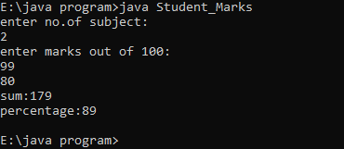

2. Java program to count the number of occurrence of an element in an array.

CODE

import java.util.Scanner;

public class Count_Occurrence

{

public static void main(String[] args) throws Exception

{

int n, x, count = 0, i = 0;

Scanner s = new Scanner(System.in);

System.out.print("Enter no. of elements you want in array:");

n = s.nextInt();

int a[] = new int[n];

System.out.println("Enter all the elements:");

for(i = 0; i < n; i++)

{

a[i] = s.nextInt();

}

System.out.print("Enter the element of which you want to count number of occurrences:");

x = s.nextInt();

for(i = 0; i < n; i++)

{

if(a[i] == x)

{

count++;

}

}

System.out.println("Number of Occurrence of the Element:"+count);

}

}

OUTPUT

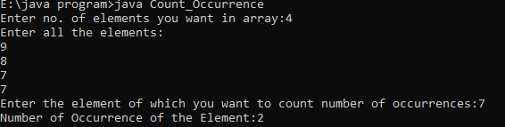

3. Java program to add two M*N matrix from user input.

CODE

import java.util.Scanner;

public class Add_Matrix

{

public static void main(String[] args)

{

int p, q, m, n;

Scanner s = new Scanner(System.in);

System.out.print("Enter number of rows in first matrix:");

p = s.nextInt();

System.out.print("Enter number of columns in first matrix:");

q = s.nextInt();

System.out.print("Enter number of rows in second matrix:");

m = s.nextInt();

System.out.print("Enter number of columns in second matrix:");

n = s.nextInt();

if (p == m && q == n)

{

int a[][] = new int[p][q];

int b[][] = new int[m][n];

int c[][] = new int[m][n];

System.out.println("Enter all the elements of first matrix:");

for (int i = 0; i < p; i++)

{

for (int j = 0; j < q; j++)

{

a[i][j] = s.nextInt();

}

}

System.out.println("Enter all the elements of second matrix:");

for (int i = 0; i < m; i++)

{

for (int j = 0; j < n; j++)

{

b[i][j] = s.nextInt();

}

}

System.out.println("First Matrix:");

for (int i = 0; i < p; i++)

{

for (int j = 0; j < q; j++)

{

System.out.print(a[i][j]+" ");

}

System.out.println("");

}

System.out.println("Second Matrix:");

for (int i = 0; i < m; i++)

{

for (int j = 0; j < n; j++)

{

System.out.print(b[i][j]+" ");

}

System.out.println("");

}

for (int i = 0; i < p; i++)

{

for (int j = 0; j < n; j++)

{

for (int k = 0; k < q; k++)

{

c[i][j] = a[i][j] + b[i][j];

}

}

}

System.out.println("Matrix after addition:");

for (int i = 0; i < p; i++)

{

for (int j = 0; j < n; j++)

{

System.out.print(c[i][j]+" ");

}

System.out.println("");

}

}

else

{

System.out.println("Addition would not be possible");

}

}

}

OUTPUT

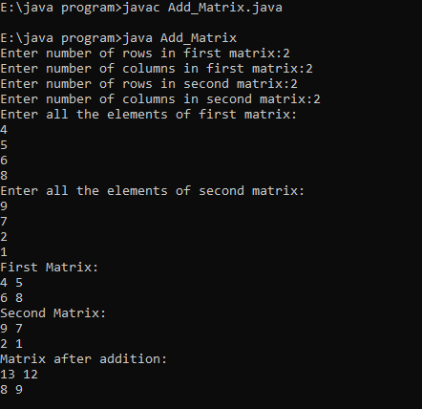

4. Java program to add complex numbers

CODE

import java.io.DataInputStream;

class Complex

{

int real;

int imag;

void read()

{

DataInputStream in=new DataInputStream(System.in);

try

{

System.out.println("enter the real part:");

real=Integer.parseInt(in.readLine());

System.out.println("enter the imaginary part:");

imag=Integer.parseInt(in.readLine());

}

catch(Exception e){}

}

void display()

{

System.out.println(real+"+"+imag+"i\n");

}

void add(Complex c2)

{

int temp_real,temp_imag;

temp_real=real+c2.real;

temp_imag=imag+c2.imag;

System.out.println("\n sum of complex numbers is"+temp_real+"+"+temp_imag+"i\n");

}

}

class Complex_5

{

public static void main(String args[])

{

Complex c1=new Complex();

Complex c2=new Complex();

System.out.println("\n enter first complex number:");

c1.read();

System.out.println("\n enter second complex number:");

c2.read();

System.out.println("\n first complex number is :");

c1.display();

System.out.println("\n second complex number is :");

c2.display();

c1.add(c2);

}

}

OUTPUT

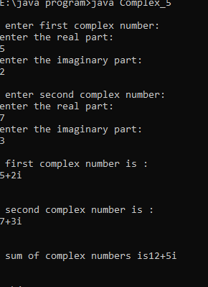

5. Java program to read a matrix from the console and check whether it is

symmetric or not.

CODEimport java.util.Scanner;

class SymmetricMatrix

{

public static void main(String args[]){

Scanner input = new Scanner(System.in);

System.out.println("Number of rows of Matrix:");

int m = input.nextInt();

System.out.println("Number of columns of Matrix:");

int n = input.nextInt();

int a[][] = new int[m][n];

System.out.println("Enter elements of The Matrix:");

for(int i =0;i < m;i++){

for(int j = 0;j<n;j++){

a[i][j] = input.nextInt();

}

}

if(m != n)

System.out.println("Matrix is not a Squre matrix");

else{

int b[][] = new int[n][m];

for(int i=0; i < n; i++){

for(int j = 0;j < m; j++){

b[i][j] = a[j][i];

}

}

int flag =0;

first:

for(int i =0; i < n; i++){

for(int j = 0; j < m;j++){

if(a[i][j] != b[i][j]){

flag =1;

break first;

}

}

}

if(flag == 1)

System.out.println("Matrix is not Symmetric");

else

System.out.println("Matrix is Symmetric");

}

}

}

import java.util.Scanner;

class SymmetricMatrix

{

public static void main(String args[]){

Scanner input = new Scanner(System.in);

System.out.println("Number of rows of Matrix:");

int m = input.nextInt();

System.out.println("Number of columns of Matrix:");

int n = input.nextInt();

int a[][] = new int[m][n];

System.out.println("Enter elements of The Matrix:");

for(int i =0;i < m;i++){

for(int j = 0;j<n;j++){

a[i][j] = input.nextInt();

}

}

if(m != n)

System.out.println("Matrix is not a Squre matrix");

else{

int b[][] = new int[n][m];

for(int i=0; i < n; i++){

for(int j = 0;j < m; j++){

b[i][j] = a[j][i];

}

}

int flag =0;

first:

for(int i =0; i < n; i++){

for(int j = 0; j < m;j++){

if(a[i][j] != b[i][j]){

flag =1;

break first;

}

}

}

if(flag == 1)

System.out.println("Matrix is not Symmetric");

else

System.out.println("Matrix is Symmetric");

}

}

}

OUTPUT

